test-run

serviceName

platform-top-service-activity

platform-top-service-es

platform-top-service-sms

platform-top-service-finance

platform-top-service-pay

platform-top-service-threadgame

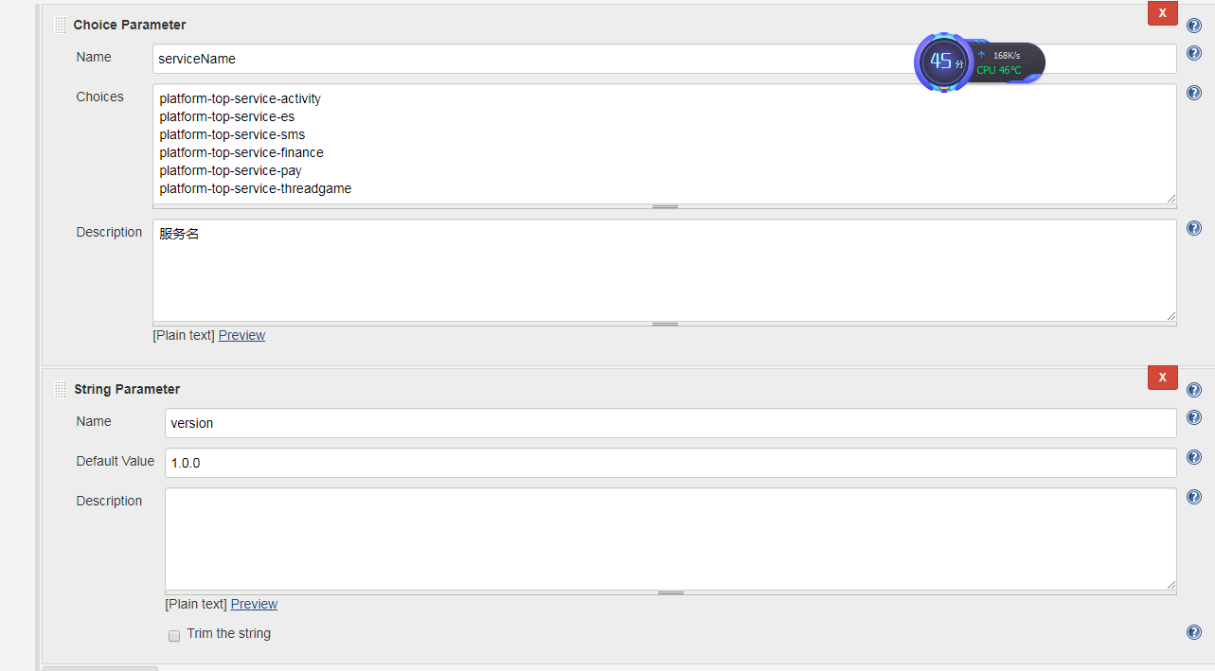

#!/bin/sh

BUILD_ID=test-run-${serviceName}

echo ${names}

echo ${serviceName}

cd /home/test/${serviceName}

#ps -ef|grep ${serviceName}

#pkill -f ${serviceName}-${version}

ps -ef|grep ${serviceName}-${version}.jar| awk '{print "kill -9 " $2}'|sh

echo "kill process..."

sleep 3